Sonoma Online NA Meeting Format:
Purpose: The purpose of this meeting is to provide continuity for addicts who are currently unable to attend meetings in person due to the current public health crisis in our area.
The format of this meeting will be a literature/discussion meeting.
Anonymity: This is an open meeting posted on the Sonoma County Narcotics Anonymous Meeting List. This meeting is not recorded and we ask that attendees also not record or screen print using any other software or device. Your name may display in the meeting, but your email address and other information will not be shown.
Technical info: Upon entry to the meeting you will be muted. You can unmute yourself by clicking the microphone in the lower left corner. You may have video display as well. If you would like to enable or disable video display you can do so by selecting it from the lower menu. The Host will mute anyone that has substantial background noise.

Meeting Format Begin:
Hello, I’m an addict and my name is ____. Welcome to the Sonoma County Online group of Narcotics Anonymous. Can we open this meeting with a moment of silence for the addict who still suffers, followed by the Serenity Prayer.
Is there anyone here attending their first NA meeting? Is there anyone celebrating a recovery related birthday?
Could someone please read:
1) Who is an addict

Who is an Addict
Most of us do not have to think twice about this question. We know! Our whole life and thinking was centered in drugs in one form or another—the getting and using and finding ways and means to get more. We lived to use and used to live. Very simply, an addict is a man or woman whose life is controlled by drugs. We are people in the grip of a continuing and progressive illness whose ends are always the same: jails, institutions, and death.

2) What is the NA Program
NA is a nonprofit fellowship or society of men and women for whom drugs had become a major problem. We are recovering addicts who meet regularly to help each other stay clean. This is a program of complete abstinence from all drugs. There is only one requirement for membership, the desire to stop using. We suggest that you keep an open mind and give yourself a break. Our program is a set of principles written so simply that we can follow them in our daily lives. The most important thing about them is that they work.
There are no strings attached to NA. We are not affiliated with any other organizations. We have no initiation fees or dues, no pledges to sign, no promises to make to anyone. We are not connected with any political, religious, or law enforcement groups, and are under no surveillance at any time. Anyone may join us, regardless of age, race, sexual identity, creed, religion, or lack of religion.
We are not interested in what or how much you used or who your connections were, what you have done in the past, how much or how little you have, but only in what you want to do about your problem and how we can help. The newcomer is the most important person at any meeting, because we can only keep what we have by giving it away. We have learned from our group experience that those who keep coming to our meetings regularly stay clean.

3) Why are we here
Before coming to the Fellowship of NA, we could not manage our own lives. We could not live and enjoy life as other people do. We had to have something different and we thought we had found it in drugs. We placed their use ahead of the welfare of our families, our wives, husbands, and our children. We had to have drugs at all costs. We did many people great harm, but most of all we harmed ourselves. Through our inability to accept personal responsibilities we were actually creating our own problems. We seemed to be incapable of facing life on its own terms.
Most of us realized that in our addiction we were slowly committing suicide, but addiction is such a cunning enemy of life that we had lost the power to do anything about it. Many of us ended up in jail, or sought help through medicine, religion, and psychiatry. None of these methods was sufficient for us. Our disease always resurfaced or continued to progress until, in desperation, we sought help from each other in Narcotics Anonymous.
After coming to NA we realized we were sick people. We suffered from a disease from which there is no known cure. It can, however, be arrested at some point, and recovery is then possible.

4) How it works
If you want what we have to offer, and are willing to make the effort to get it, then you are ready to take certain steps. These are the principles that made our recovery possible.
1 - We admitted that we were powerless over our addiction, that our lives had become unmanageable.
2 -We came to believe that a Power greater than ourselves could restore us to sanity.
3 - We made a decision to turn our will and our lives over to the care of God as we understood Him.
4 - We made a searching and fearless moral inventory of ourselves.
5 - We admitted to God, to ourselves, and to another human being the exact nature of our wrongs.
6 - We were entirely ready to have God remove all these defects of character.
7 - We humbly asked Him to remove our shortcomings.
8 - We made a list of all persons we had harmed, and became willing to make amends to them all.
9 - We made direct amends to such people wherever possible, except when to do so would injure them or others.
10 - We continued to take personal inventory and when we were wrong promptly admitted it.
11 - We sought through prayer and meditation to improve our conscious contact with God as we understood Him, praying only for knowledge of His will for us and the power to carry that out.
12 - Having had a spiritual awakening as a result of these steps, we tried to carry this message to addicts, and to practice these principles in all our affairs.
This sounds like a big order, and we can’t do it all at once. We didn’t become addicted in one day, so remember—easy does it.
There is one thing more than anything else that will defeat us in our recovery; this is an attitude of indifference or intolerance toward spiritual principles. Three of these that are indispensable are honesty, open-mindedness, and willingness. With these we are well on our way.
We feel that our approach to the disease of addiction is completely realistic, for the therapeutic value of one addict helping another is without parallel. We feel that our way is practical, for one addict can best understand and help another addict. We believe that the sooner we face our problems within our society, in everyday living, just that much faster do we become acceptable, responsible, and productive members of that society.
The only way to keep from returning to active addiction is not to take that first drug. If you are like us you know that one is too many and a thousand never enough. We put great emphasis on this, for we know that when we use drugs in any form, or substitute one for another, we release our addiction all over again.
Thinking of alcohol as different from other drugs has caused a great many addicts to relapse. Before we came to NA, many of us viewed alcohol separately, but we cannot afford to be confused about this. Alcohol is a drug. We are people with the disease of addiction who must abstain from all drugs in order to recover.

5) The Twelve Traditions of NA
We keep what we have only with vigilance, and just as freedom for the individual comes from the Twelve Steps, so freedom for the group springs from our traditions.
As long as the ties that bind us together are stronger than those that would tear us apart, all will be well.
1. Our common welfare should come first; personal recovery depends on NA unity.
2. For our group purpose there is but one ultimate authority—a loving God as He may express Himself in our group conscience. Our leaders are but trusted servants; they do not govern.
3. The only requirement for membership is a desire to stop using.
4. Each group should be autonomous except in matters affecting other groups or NA as a whole.
5. Each group has but one primary purpose—to carry the message to the addict who still suffers.
6. An NA group ought never endorse, finance, or lend the NA name to any related facility or outside enterprise, lest problems of money, property, or prestige divert us from our primary purpose.
7. Every NA group ought to be fully self-supporting, declining outside contributions.
8. Narcotics Anonymous should remain forever nonprofessional, but our service centers may employ special workers.
9. NA, as such, ought never be organized, but we may create service boards or committees directly responsible to those they serve.
10. Narcotics Anonymous has no opinion on outside issues; hence the NA name ought never be drawn into public controversy.
11. Our public relations policy is based on attraction rather than promotion; we need always maintain personal anonymity at the level of press, radio, and films.
12. Anonymity is the spiritual foundation of all our traditions, ever reminding us to place principles before personalities.

In adherence to the 7th tradition which states “Every NA group ought to be fully self-supporting, declining outside contributions.” This meeting does collect a 7th tradition. It pays for the cost of the online meeting system (~$15/month) and anything left over will be donated to the Sonoma County Area of Narcotics Anonymous>Northern California Region> World to support NA both locally and worldwide. The 3rd Tradition states that “the only requirement for membership is the desire to stop using”. If you are unable or choose not to contribute monetarily that is absolutely ok and can still contribute through your participation in the meeting.

The logistics for donating to the 7th tradition. This meeting has a Venmo account and you can donate through the Venmo App to the User Account named: Online-Meeting
Please be sure to change setting to Private
1)Open Venmo App 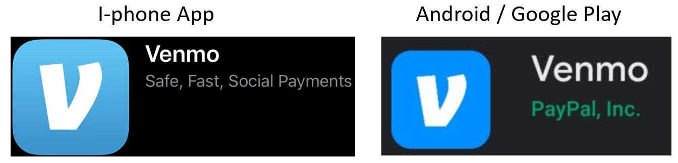 Select Pay button 
2) Search for Online Meeting
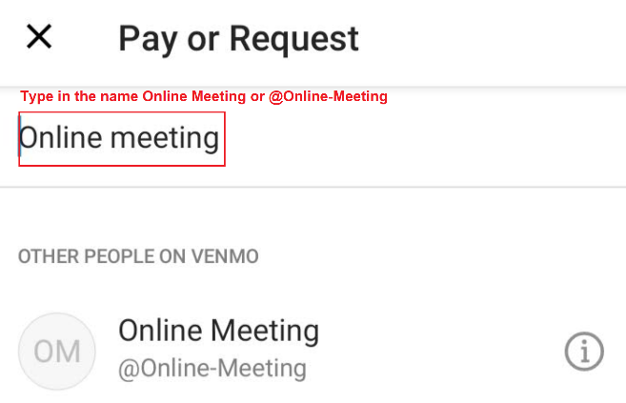
3) Input amount, add comment, change setting to PRIVATE, select Pay. 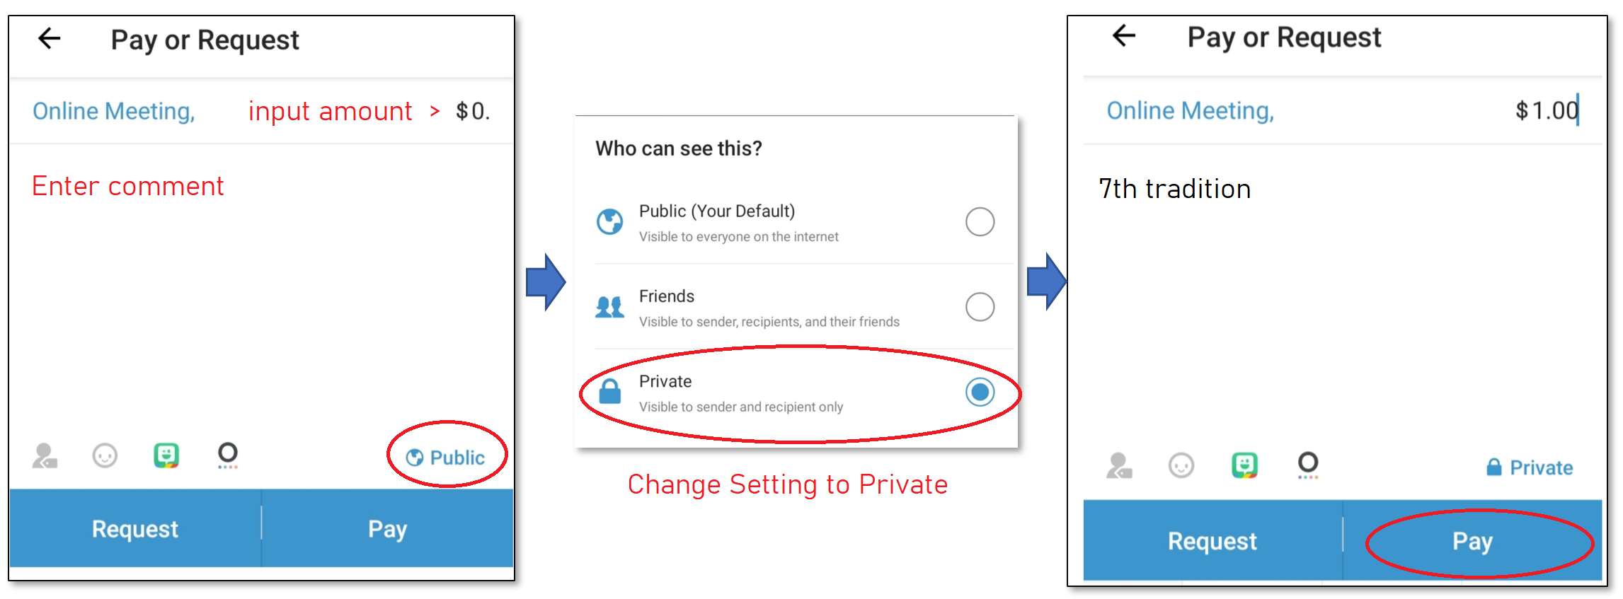
If you require more assistance with this please email sonomaonlinena@gmail.com after the meeting to request a copy of these steps.

Sonoma Online NA as a group has decided to provide proof of attendance to those who request it. For proof of attendance please email sonomaonlinena@gmail.com to request proof of attendance. We will reply to your email after the meeting with proof of attendance. In order to keep theses online meetings organized please include the day of the week in the subject line. For example, if today is Saturday please spell out the full word Saturday in the email subject. In the body of the email please request proof of attendance and include the keyword spiritual principal that the secretary has selected for this meeting.
Today’s spiritual principal is: Love
Example Email:
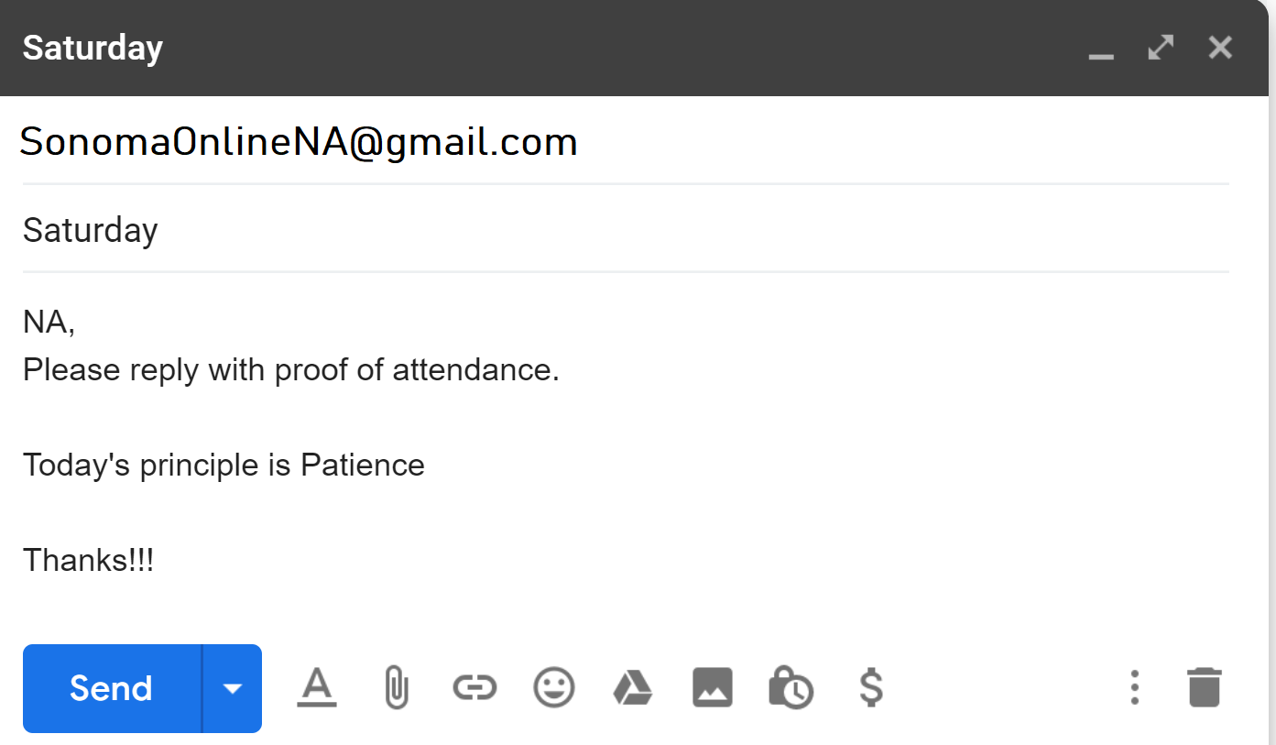

Are there any other NA related announcements?
Now we will [Read some Narcotics Anonymous literature] [Introduce Speaker] [Pick Topics] and then open the meeting for discussion.
Please keep your shares from 3-5 minutes so that all who wish to participate can. You can participate by speaking up in the meeting and/or virtually “raising your hand”. If more than one person speaks the host will select one of the members to speak and then ask the other member to us the hand raise function to identify that they would like to speak next.

Burning desire? Does anyone feel like they may use if they do not speak-up now? If so please speak up.
In closing – we ask that who you hear/see here stays here and to respect all members anonymity.
Will a member read Just for Today?

Just For Today
Just for today my thoughts will be on my recovery, living and enjoying life without the use of drugs.
Just for today I will have faith in someone in NA who believes in me and wants to help me in my recovery.
Just for today I will have a program. I will try to follow it to the best of my ability.
Just for today through NA I will try to get a better perspective on my life.
Just for today I will be unafraid, my thoughts will be on my new associations, people who are not using and who have found a new way of life. So long as I follow that way, I have nothing to fear.

Since we are not in person and cannot socialize after the meeting – the meeting will remain online for 10 minutes in case people would like to chat/socialize. Please be mindful that others may hear your conversations but we would like to give some time to allow more communication and/or chat.
Let’s close the meeting with the NA prayer of ___choice.

