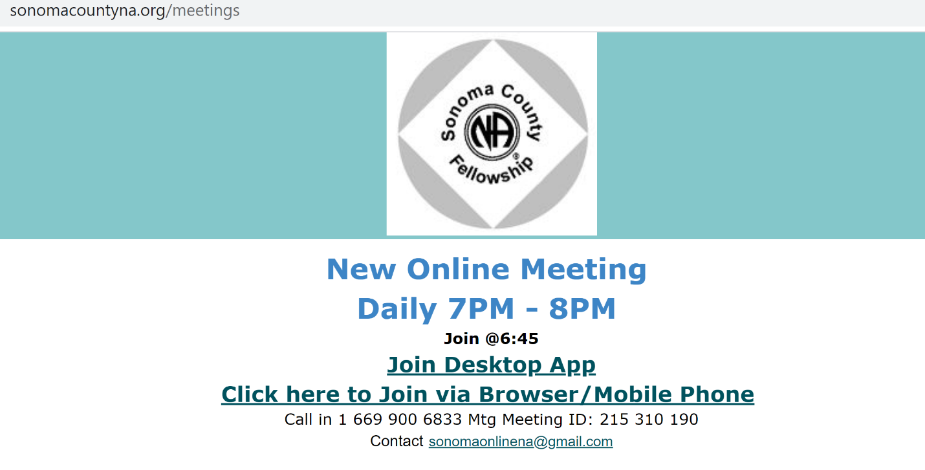
This document serves as proof of attendance*.

Meeting Date: Click or tap to enter a date.

Proof of Attendance Code: SUN-Choose an item.-Choose an item.

*The host of the meeting provides a keyword to attendees. Anyone requesting proof of attendance can email the group with the keyword specific to the meeting. Each document will have the unique proof of Attendance code listed above.

